Checksum

1. Check + sum
2. Sender side – Checksum creation
3. Receiver side – Checksum validation

Checksum – operation at sender side

1. Break the original message into k number of blocks with n bits in each block
2. Sum all the k data blocks
3. Add the carry to the sum if any
4. Do 1s complement to the sum = Checksum

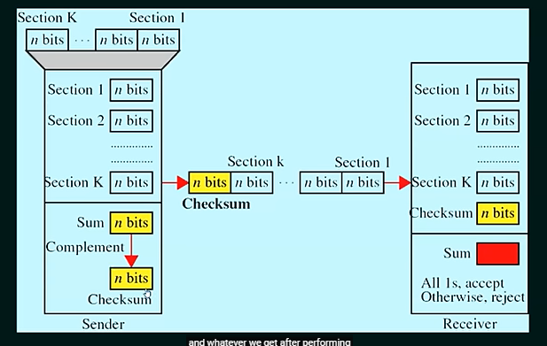

Example

Data:

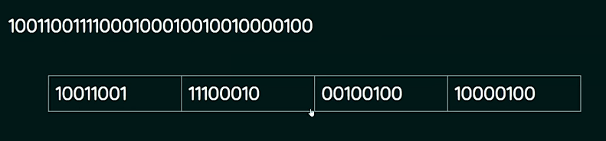

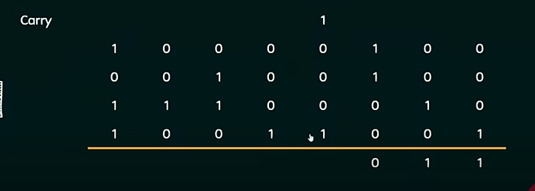

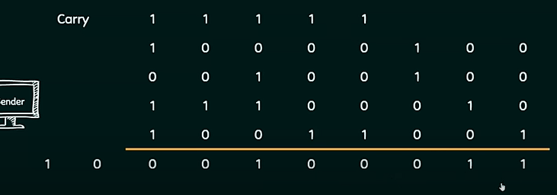

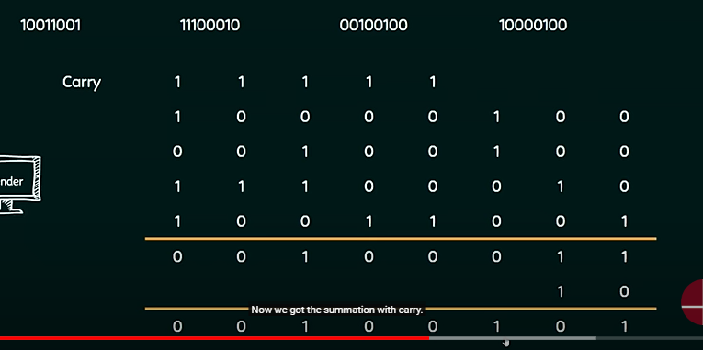

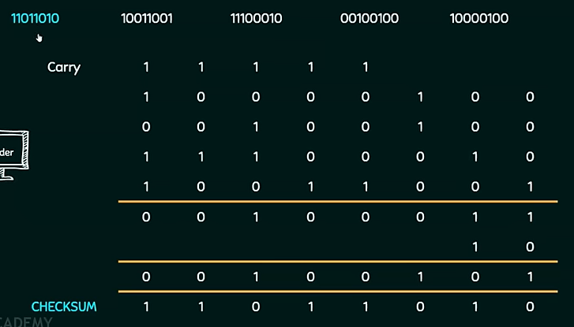

Receiver:

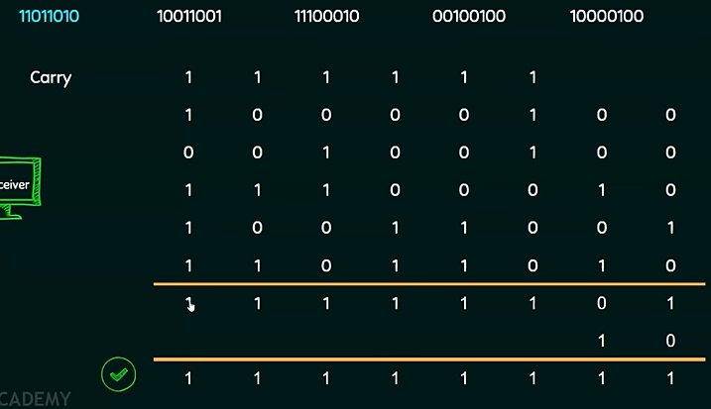

Performance of checksum

1. The checksum detects all errors involving an odd number of bits.
2. It detects most errors involving an even number of bits.
3. If one or more bits of a segment are damaged and the corresponding bits of opposite value in a second segment are also damaged, the sum of those columns will not change and the receiver will not detect the errors.